Question 6-To Calculate Hotel Tariff

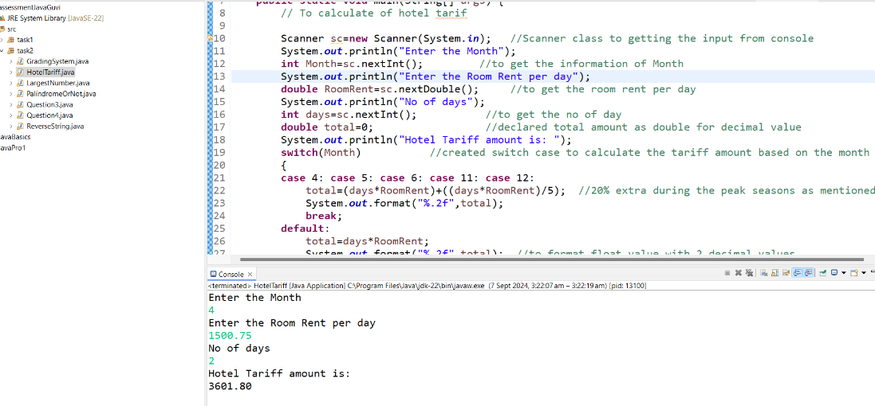

Question 7-Largest number among 3 numbers

